**Practical 7:**

**Write a Python program to read data from a CSV file, perform simple data analysis, and generate basic insights. (Use Pandas is a Python library)**

import pandas as pd

df = pd.read_csv('student.csv')

print("Columns:", df.columns)

df.columns = df.columns.str.strip()

print(df.info())

print(df.head())

print(df.select_dtypes(include='number').describe())

print(df.isnull().sum())

print(df.select_dtypes(include='number').corr())

import matplotlib.pyplot as plt

df['Score'].hist(bins=20, color='skyblue', edgecolor='black')

plt.title('Histogram of Score')

plt.show()

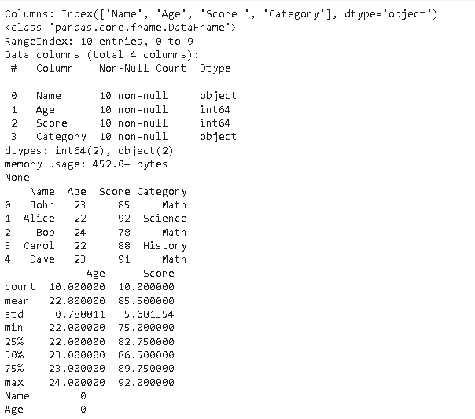

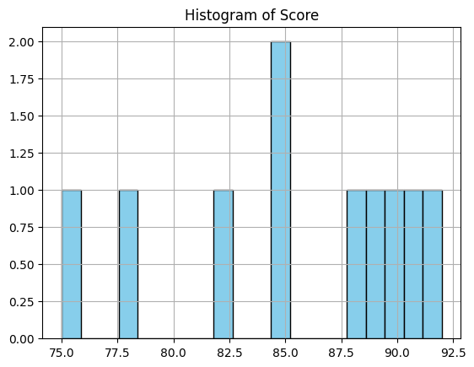

**Practical 8.a)**

**Perform data visualization using Python on any sales data.**

import pandas as pd

import matplotlib.pyplot as plt

import seaborn as sns

data = {

'Date': ['2025-01-01', '2025-01-02', '2025-01-03', '2025-01-04', '2025-01-05',

'2025-01-06', '2025-01-07', '2025-01-08', '2025-01-09', '2025-01-10'],

'Product': ['Product A', 'Product B', 'Product A', 'Product C', 'Product B',

'Product A', 'Product C', 'Product B', 'Product A', 'Product C'],

'Sales': [50, 30, 70, 90, 60, 80, 50, 40, 60, 30],

'Revenue': [500, 450, 700, 900, 900, 800, 750, 600, 600, 450]

}

df = pd.DataFrame(data)

df['Date'] = pd.to_datetime(df['Date'])

plt.figure(figsize=(12, 8))

plt.subplot(2, 2, 1)

sns.barplot(x='Product', y='Sales', data=df, palette='viridis')

plt.title('Total Sales per Product')

plt.subplot(2, 2, 2)

sns.lineplot(x='Date', y='Sales', data=df, marker='o', color='b')

plt.title('Sales Trend Over Time')

product_sales = df.groupby('Product')['Sales'].sum()

plt.subplot(2, 2, 3)

product_sales.plot.pie(autopct='%1.1f%%', startangle=90, cmap='Set3')

plt.title('Sales Distribution by Product')

plt.subplot(2, 2, 4)

sns.scatterplot(x='Sales', y='Revenue', data=df, hue='Product', palette='deep')

plt.title('Sales vs Revenue')

plt.tight_layout()

plt.show()

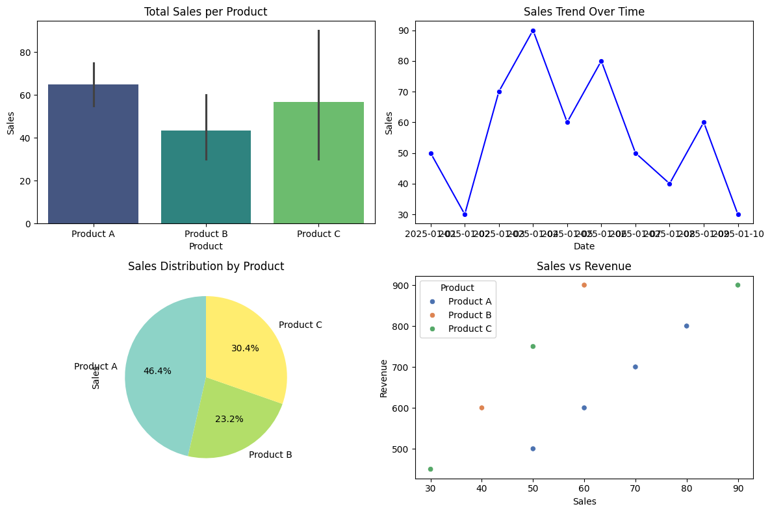

Practical 1:

1. Perform the analysis for the following: a. Import the data warehouse data in Microsoft Excel and create the Pivot table and Pivot Chart.

b. Import the cube in Microsoft Excel and create the Pivot table and Pivot Chart to perform data analysis.

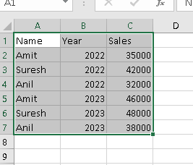

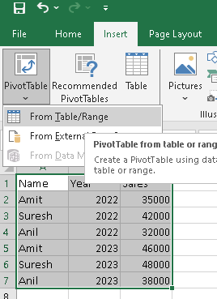

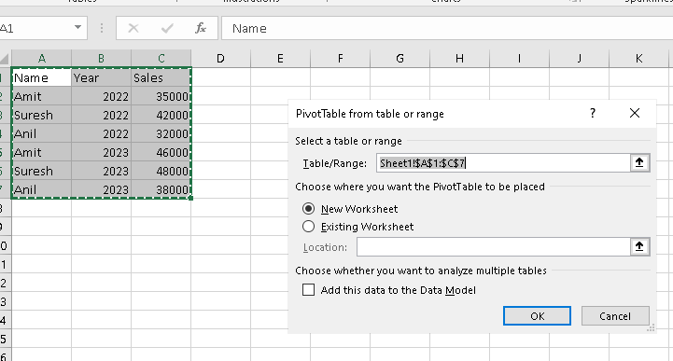

Click on ok button.

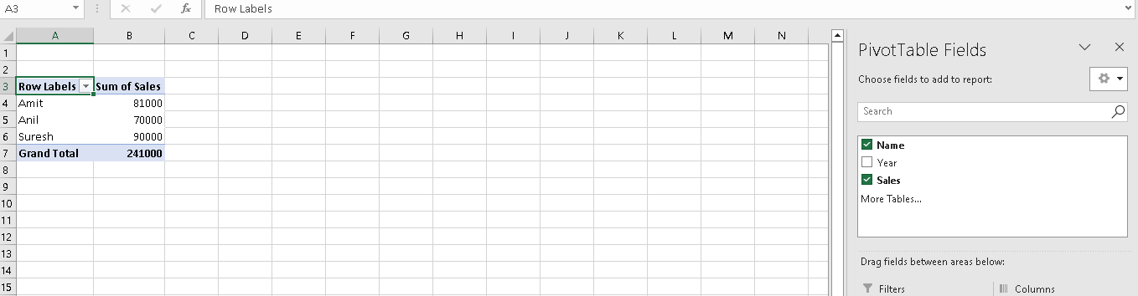

Click on Piovt Chart and select any chart.

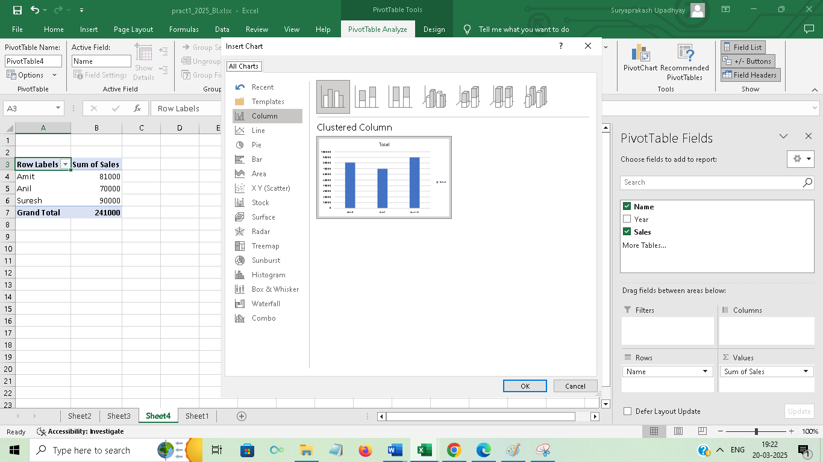

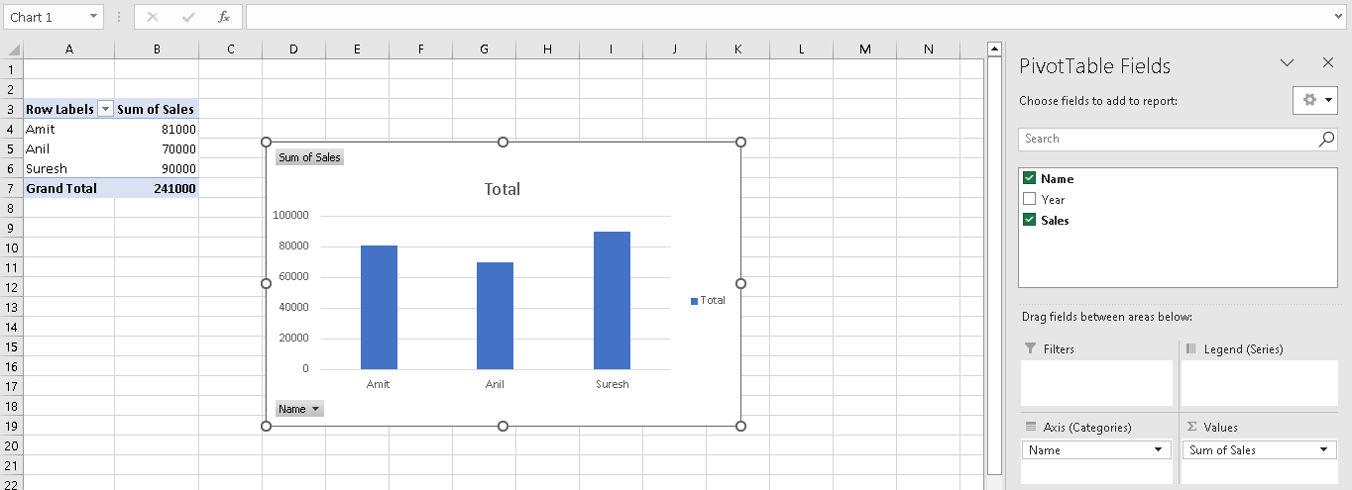

1.b)

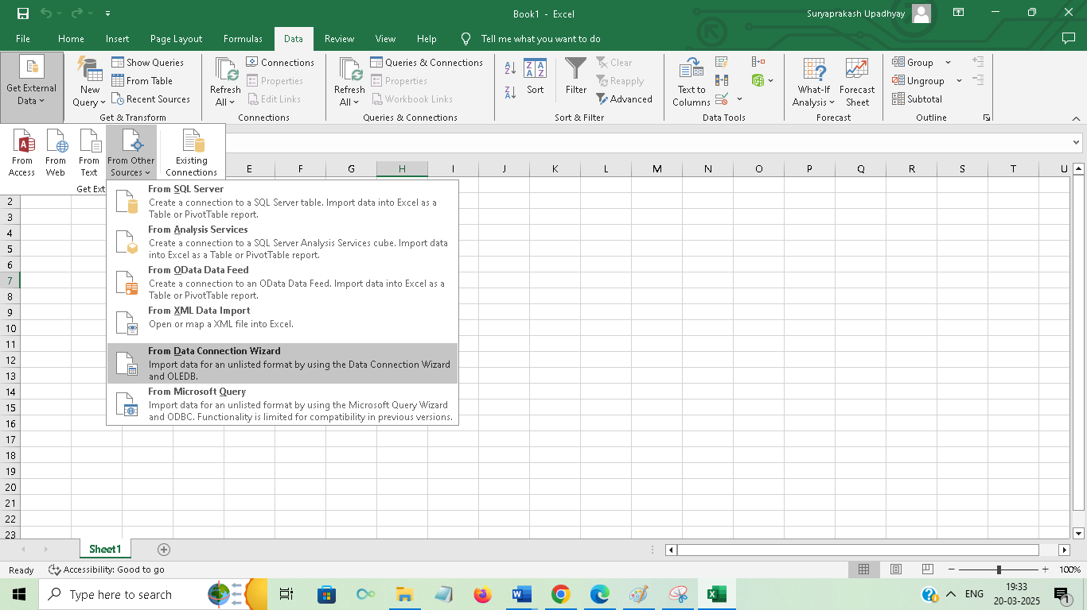

Click on From Data Connection Wizard

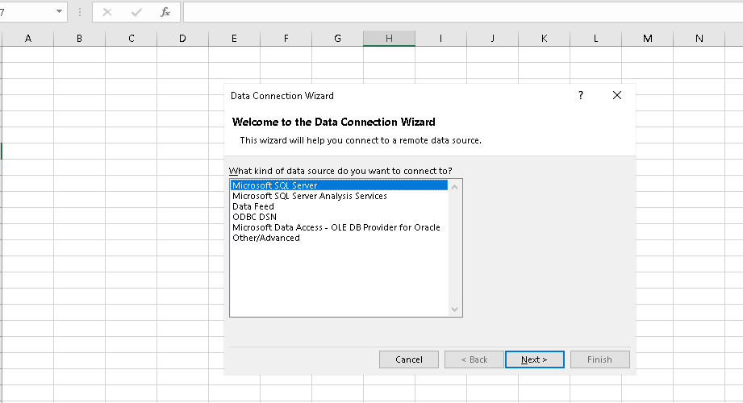

Select on Microsoft SQL Server

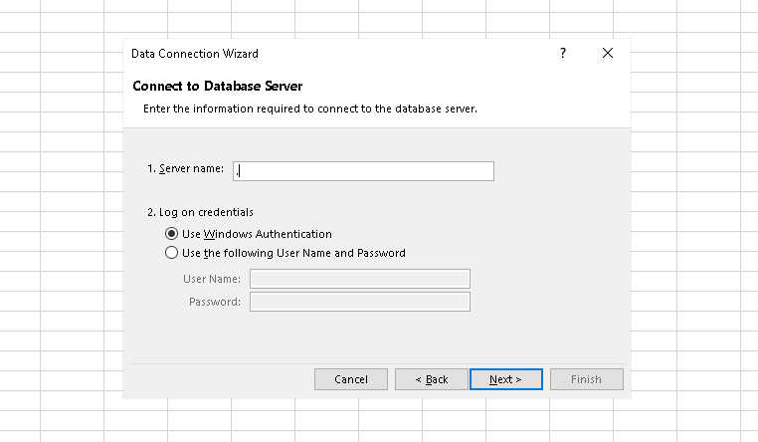

Put Dot(.) in Server name and click on next.

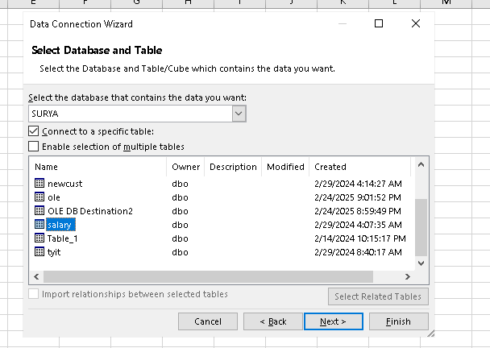

Select your database from sql server and table from sql server and click on next after that click on finish . you can create database and table in sql server by using SQL server management studio.

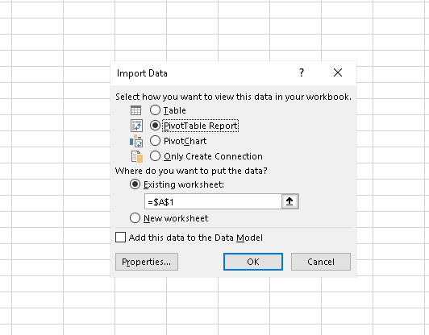

Select PiovtTable Report and click on ok.

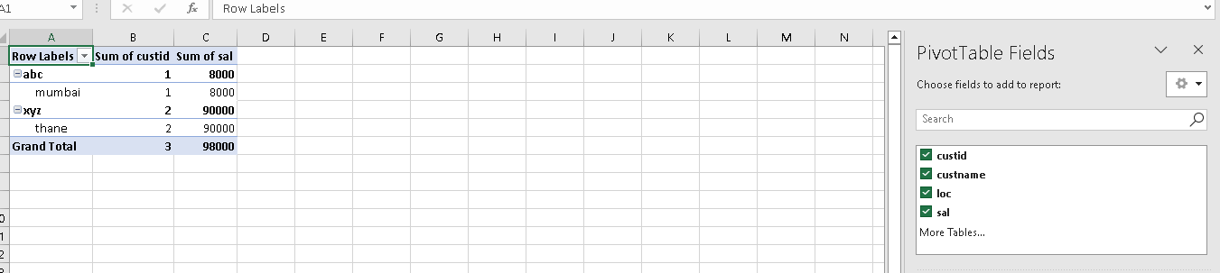

Your data can be imported from sql server to excel pivot table. Now click on pivot chart.

